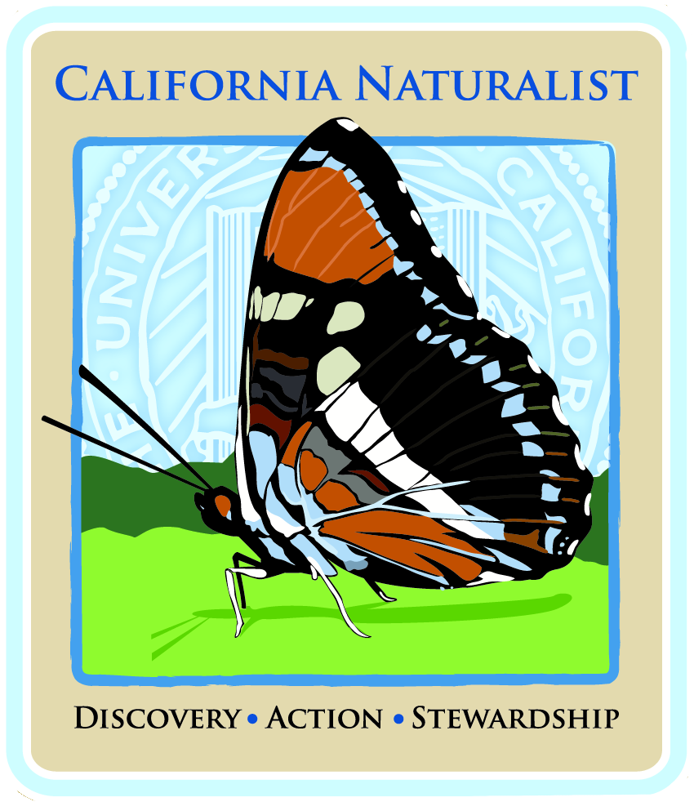
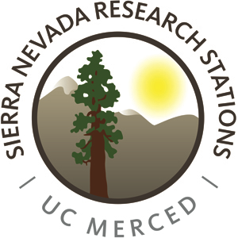
California Naturalist Central Sierra: Yosemite Immersion Class
Sunday, November 1 – Saturday, November 7, 2015
UC Merced Sierra Nevada Research Institute – Yosemite Field Station
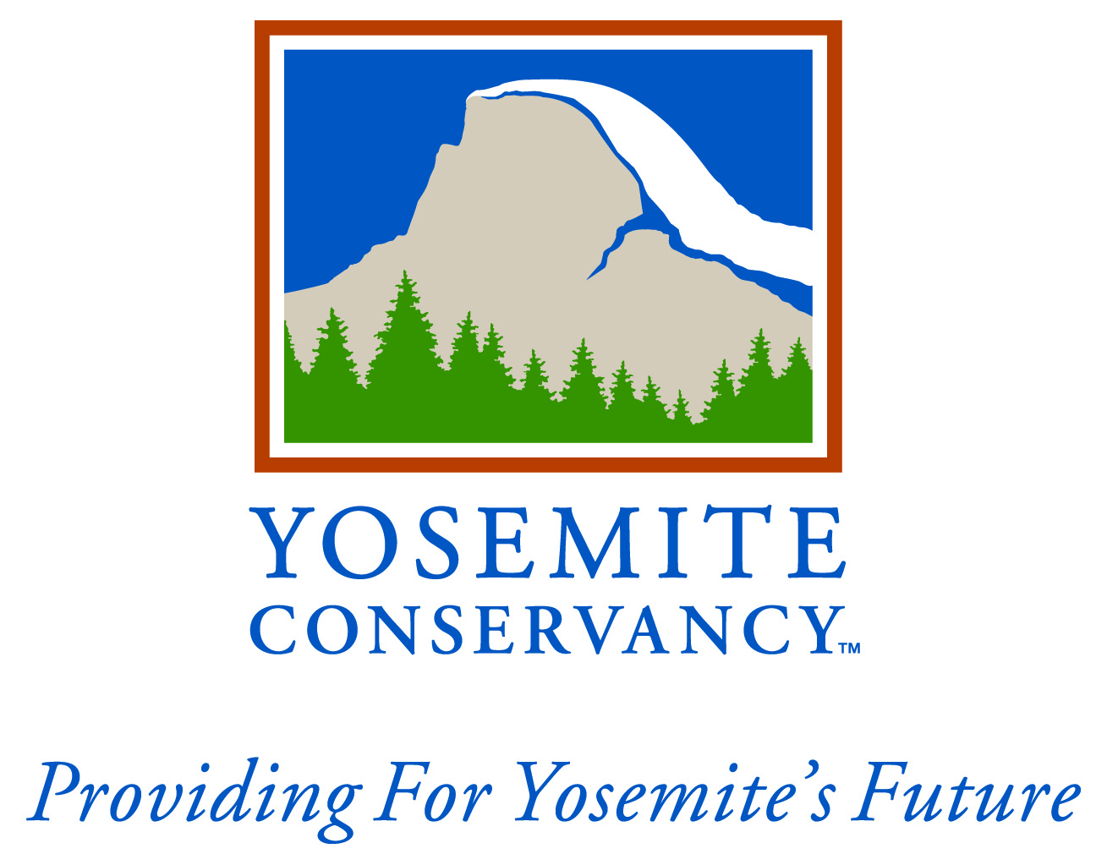
Class Syllabus (Note: Class Meeting Dates Confirmed;
Other Details Subject to Change)

Lead Instructors/Course Facilitators:

Pete Devine, Yosemite Conservancy naturalist; PDevine@yosemiteconservancy.org
Jacob Croasdale, UC Merced; jcroasdale@ucmerced.edu
Kaitlin Lubetkin, Sierra Nevada Research Stations; klubetkin@umerced.edu

Guest Lecturers:
Tim Kuhn, Yosemite National Park hydrologist
Steven Lee, USGS
Len Nielson, CAL FIRE
Greg Stock, Yosemite National Park geologist
Andie Thrams, visual artist

About the Course:
California Naturalist is a program developed by the University of California Cooperative Extension to foster eco-literacy and a committed corps of volunteer naturalists and citizen scientists trained and ready to take an active role in natural resource conservation, education, and restoration.

This course will be a week-long immersion training course that offers participants content specifically focused on the ecosystem linkages of the Sierra Nevada, with an emphasis on Yosemite National park. This 40-hour course consists of presentations, field trips, and lively collaborative discussions about individual components of the ecosystem, including influences on and interconnections with the whole system. Led by scholars and professionals in their fields, these sessions introduce and expand on the roles and importance of each entity, using examples from Sierra communities while relating to California’s unique ecology and natural history. Time in the field with researchers and professionals gives participants first-hand experiences in seeing nature from a scientist’s perspective. Participants will also have an opportunity to interpret what they see to make meaning for themselves and others.

The course will take place in a residential setting at the Sierra Nevada Research Station in Yosemite. Lodging is included in the course fee and is a requirement for all participants since activities begin early each morning and continue through the evening. Participants will stay in semi-rustic cabins in the small town of Wawona at the southern end of Yosemite. The course fee also includes all meals, with six catered dinners.

Participants will become part of the venerable tradition of naturalists throughout history. By the end of this course, participants will be able to:
- Understand what it means to be a naturalist.
- Integrate knowledge about the interconnectedness of abiotic and biotic factors and their influence on the natural history of the Sierra Nevada and Yosemite National Park.
- Demonstrate skills in making and recording natural history observations in a field notebook.
- Apply knowledge of the Sierra Nevada ecosystem to local and global environmental issues.

Capstone Project
Certification as a California Naturalist requires that each participant plan and complete a Capstone Project. A Capstone Project should be something that can be completed in a relatively short time period (eight hours) and must focus on stewardship, education/interpretation, citizen science, or program support. Participants may work individually or in teams to design and implement their Capstone Projects. Since time is limited during the week, participants in the immersion course will need to design a Capstone Project to implement after the course. At the end of the week, each participant will give a 5-15 minute oral presentation describing a fully fleshed plan for how they will complete their Capstone Project.

Participation
Participants will be required to attend class meetings and field trips during this one-week immersion course, and to complete a Capstone Project and presentation, in order to obtain the California Naturalist certificate. The course consists of required pre-course reading and full participation throughout the week. While each day is filled with new content and activities, the alternation of presentations, field sessions, and hands-on activities sets a comfortable pace with time for reflection and taking care of personal needs. The residential format allows participants to develop deeper connections with the area and fosters a sense of camaraderie with fellow participants.

Volunteer Service:
After completing the California Naturalist Yosemite training program, participants are expected to complete 40 hours of volunteer service relating to California’s natural or environmental cultural history (stewardship, education/interpretation, citizen science, or program support). Hours spent planning, developing, and completing the Capstone Project count toward this 40-hour requirement. We provide information on local opportunities, and students are encouraged to participate in and conduct activities with agencies within their own communities.

Naturalist Field Notebook:
Naturalists document their field observations with notes and sketches in a detailed Field Notebook. It is a course requirement to keep a Field Notebook during the course and hopefully beyond. Keeping a Field Notebook, and better yet a detailed field journal, is one of the best ways of recording observations for future reflection and for fostering continued learning and development as an experienced naturalist. Participants also record observations in an online field data collection and social networking tool called iNaturalist.

Registration and Fees:
The course registration fee is $750. Class size is limited to 25 participants. Fees include lodging, meals, course instruction and field sessions, graduation certificate, California Naturalist registration, website support, and lapel pin. Students will be provided a nature journal, but will need to purchase the required text, The California Naturalist Handbook, prior to the start of the course.

For an additional fee, Continuing Education Credits (CEUs) are available through UC Davis Extension to teachers and undergraduate students who successfully complete the course. If you desire CEUs, please speak to the course coordinator.

Refund policy
4 weeks before the course (10/5/15): full refund minus a $25 service charge
2 weeks before the course (10/19/15): refund minus lodging ($120) and a $25 service charge. Lodging will be refunded if we can find an applicant on the waiting list able to take the place of the person canceling.
1 week before the course (10/26/15): no refund unless we can find an applicant on the waiting list able to take the place of the person canceling. If we can find a replacement participant, refund minus a $25 service charge.

Required Text:
The California Naturalist Handbook, UC Press, 2013

Meeting Times and Locations:
The California Naturalist Yosemite immersion class will meet at the Sierra Nevada Research Station in Wawona, California (just inside the south entrance to Yosemite National Park) midday on Sunday, November 1. We will depart after lunch on Saturday, November 7, 2015.

The course schedule is outlined below. Guest speakers will present information and lead discussions about specific topics. Field sessions correlate with each topic. Readings listed are from the California Naturalist Handbook. Homework questions and assignments will be available at a later date.

Day 1: Sunday, November 1st
11:30 – 1:00 Cabin assignments, unpack, settle in
Location: Sierra Nevada Research Stations, Yosemite Field Station
7799 Chilnualna Falls Road, Wawona, 95389

1:00 – 2:30 Welcome, introduction to the California Naturalist Program, Volunteer Management System, and iNaturalist
Location: Field Station classroom
Staff: Pete Devine, Jacob Croasdale, Kaitlin Lubetkin
Reading: Chapter 1, California Natural History and the Role of Naturalists

2:30 – 5:00 Guided Journaling Activity
Location: Field Station classroom, Wawona area
Staff: Andie Thrams, visual artist
Reading: Chapter 1, California Natural History and the Role of Naturalists

5:30 Dinner

7:00 – 9:00 Nine Paradigms that Everyone Needs to Know about Yosemite
Location: Field Station classroom
Staff: Pete Devine
Reading: Chapter 8, Interpretation, Collaboration, and Citizen Science

Day 2: Monday, November 2nd
Prior to 8:00 Breakfast, assemble food for lunch

8:00 – 12:00 Geology
Location: Field Station classrooom
Staff: Greg Stock, Yosemite National Park geologist
Reading: Chapter 2, Geology, Climate, and Soils

12:00 Lunch (Glacier Point)

12:30 – 3:00 Journaling, and iNaturalist
Location: Field Station classroom, Wawona area
Staff: Pete Devine, Kaitlin Lubetkin
Reading: none

3:00 – 4:00 Capstone Preparation
Location: Field Station classroom
Staff: Pete Devine, Kaitlin Lubetkin
Reading: none

5:30 Dinner

7:00 – 8:00 Homework, discussion, etc.
Location: Field Station classroom
Staff: Participants
Reading: Chapters 1, 8, & 2

Day 3: Tuesday, November 3rd
Prior to 8:00 Breakfast, assemble food for lunch

8:00 – 9:00 Meet at classroom, carpool to Sentinel Bridge

9:00 – 12:00 Water
Location: Yosemite Valley
Staff: Tim Kuhn, Yosemite National Park hydrologist
Reading: Chapter 3, Water

12:00 Lunch (Yosemite Valley)

1:00 – 4:00 Plants
Location: Tuolumne Grove
Staff: Kaitlin Lubetkin, Sierra Nevada Research Stations
Reading: Chapter 4, Plants

5:30 Dinner

8:00 – 9:00 Homework, discussion, etc.
Location: Field Station classroom
Staff: Participants
Reading: Chapters 3 & 4

Day 4: Wednesday, November 4th
Prior to 9:00 Breakfast, assemble food for lunch

9:00 – 12:00 Forest, Woodland, and Range Resources and Management
Location: Chowchilla Mountain Road, Wawona
Staff: Len Nielson, CAL FIRE
Reading: Chapter 5, Forest, Woodland, and Range Resources and Management

12:00 Lunch (Wawona)

1:00 – 2:00 Animals
Location: Field Station classroom
Staff: Steven Lee, USGS
Reading: Chapter 6, Animals

2:00 – 4:00 Journaling, iNaturalist
Location: Wawona Meadow
Staff: Participants
Reading: none

4:00 Free time, work on capstone

5:30 Dinner

7:00 – 8:00 Homework, discussion, etc.
Location: Field Station classroom
Staff: Participants
Reading: Chapters 5 & 6
Day 5: Thursday, November 5th
Prior to 8:30 Breakfast, assemble food for lunch

8:30 – 4:00 Animal Hike with Focus on Avifauna; lunch on the hike
Location: Wawona area
Staff: Pete Devine
Reading: Chapter 6, Animals

4:45 Meet at Field Station office, carpool to Oakhurst

5:30 Dinner in Oakhurst (El Cid)

Day 6: Friday, November 6th
Prior to 9:00 Breakfast, assemble food for lunch

9:00 – 10:30 Energy and Global Environmental Issues
Location: Field Station classroom
Staff: Pete Devine
Reading: Chapter 7, Energy and Global Environmental Issues

10:30 Free time, work on capstone, iNaturalist, journaling

12:00 Lunch (Wawona)

1:00 – 2:00 Work on capstone

2:00 – 5:00 Capstone Presentations
Location: Field Station classroom
Staff: Participants
Reading: none

5:30 Dinner

7:00 – 9:00 Astronomy
Location: Meet at field station office
Staff: Pete Devine
Reading: none

Day 7: Saturday, November 7th
Prior to 10:00Breakfast, pack, clean

10:00–11:00 Capstone Presentations
Location: Field Station classroom
Staff: Participants
Reading: none

11:00–12:00 Wrap up
Location: Field Station classroom
Staff: Participants
Reading: none

12:00 Graduation lunch (Wawona)

